import numpy as np

import pandas as pd

exc = pd.read_excel('Salaries t.xlsx', sheet_name='Salaries',index_col='Id')

1.

exc.loc[:, 'BasePay'].mean()

66325.44884050643

2.

exc.loc[:, 'OvertimePay'].max()

245131.88

3.

df = exc.set_index('EmployeeName').loc['JOSEPH DRISCOLL']

df.loc['JobTitle']

'CAPTAIN, FIRE SUPPRESSION'

4.

df = exc.set_index('EmployeeName').loc['JOSEPH DRISCOLL']

df.loc['TotalPayBenefits']

270324.91

5.

df = exc.sort_values(by="TotalPayBenefits", ascending=False)

df.head(1)

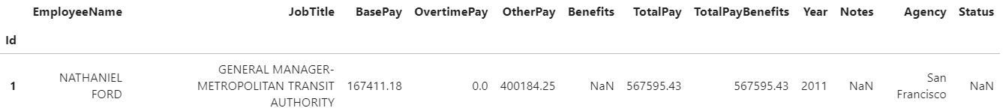

6.

df = exc.sort_values(by="TotalPayBenefits", ascending=False)

df.tail(1)



7.

aver = exc.groupby("Year")

aver['BasePay'].mean()

Year

2011 63595.956517

2012 65436.406857

2013 69630.030216

2014 66564.421924

Name: BasePay, dtype: float64

8.

exc['JobTitle'].unique() # чисто все виды проф

exc['JobTitle'].nunique() #кол-во уникальных

2159

9.

exc['JobTitle'].value_counts().head(5)

Transit Operator 7036

Special Nurse 4389

Registered Nurse 3736

Public Svc Aide-Public Works 2518

Police Officer 3 2421

Name: JobTitle, dtype: int64

10.

chef = exc['JobTitle'].str.contains('Chief',regex=True,case=False)

chef[chef == True].sum()

627

11.

sal = exc[['Year', 'JobTitle']]

sal = sal[sal['Year']==2013]

sal = sal['JobTitle'].value_counts()

sal = sal[sal == 1]

sal.sum()

202